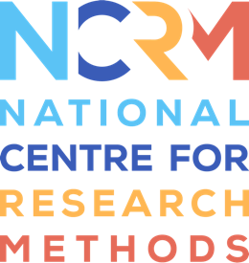
‘I am’ Digital Stories

Strengths-based mapping for ‘I am’ Digital Stories: 7 areas to focus on.
Create a map about the child or young person: what they like and are good at, and where they may need support using the headings below. This map should be created with or by the person as much as possible and may also involve people who know the person well. This will help when planning the filming.
‘I am’ Digital Stories framework | Add your thoughts here
1.Spaces
Where does the child or young person like to be or explore?
Outdoor: the playing fields, playground, benches, going for walks, community spaces
Inside: at tables or on a sofa, or any young person-led activities, classrooms or activity rooms, library, specific staff members office, or places in the home.
2. People and interactions
How do young people like to spend their time and who do they interact with?
Young people will interact in different ways with adults and peers. So this section could include staff who work with the person, family members, and friends. The person may also like to spend time by themselves. Interactions can be young person-led or adult-led.

3. Independence and agency
What does the young person choose to do for themselves?
This can include exploring, requesting, initiating, choosing, travelling, deciding, acting upon an interest or hobby.

4. Objects and interests
What is the young person really interested in and like doing?
Look out for preferred books, activities, use of equipment, clothing, use of outdoor spaces, and the importance of touch or sensory stimulation and responses.
5. Communication and expression
In what ways does the young person express themselves?
This could be verbal or non-verbal and directed at the self or others. This could involve alternative and augmentative communication (AAC), text, speech, gesture.

6. Support
Where does the young person need support? What strategies support the young person effectively?
Include some indication of the areas where the young person needs support to encourage their participation and progression. For example, support with lesson transitions, unstructured time, social communication, learning aids, planning.
Show what kinds of support enable the person to have a good day: this could be support from people, equipment (e.g. assistive technologies), or information.
7. Skills and capabilities
What is the young person good at?
There are many things that could be shown here e.g. art, sports, science, maths, humour, storytelling, specific subject interests, public speaking, helping others, computing, specific school subjects, external hobbies and extra-curricular activities.

National Centre for Research Methods (NCRM)
Social Sciences
Murray Building (Bldg 58)
University of Southampton
Southampton SO17 1BJ
United Kingdom
Web www.ncrm.ac.uk
Email info@ncrm.ac.uk
Tel +44 23 8059 4539
Twitter @NCRMUK

