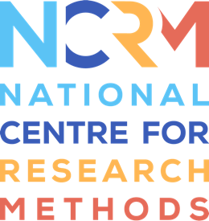
‘I am’ Digital Stories
How could an ‘I am’ Digital Story method be used in your research? Key questions to consider.
Key concept | Key questions | Key considerations for your research related to these questions
Marginalised voices | In what ways might the people you want to include in your research be or feel marginalised from participation and having their voices heard?  What are the dominant narratives that need to be countered with more holistic representations of people’s lives, identity, and personhood?
Knowledge co-construction | Thinking about who your storytellers might be, what contexts are important for understanding more about them?  Who is involved in those contexts and may be involved in the co-construction of the ‘I am…’ Digital Stories with the person?  What issues might this raise for your research?
Strengths-based approach | How could this strengths-based framework be applied with the people and contexts that you are working with?  Are there ways in which the framework could be adapted or extended to reflect the specific contexts and needs of the people you are working with?  Are there aspects of the framework that may be easier or more challenging to represent in the context(s) in which you are researching?
Perspective-taking | How will you enable others to see the world from the person’s point of view?  How does the person / people you are working with communicate and experience the world? What implications does this have for how to facilitate their voice and agency in the creation of an ‘I am’ Digital Story?  How will you seek to ensure that the Story is what the storyteller would want other people to know about them?

National Centre for Research Methods (NCRM)
Social Sciences
Murray Building (Bldg 58)
University of Southampton
Southampton SO17 1BJ
United Kingdom
Web www.ncrm.ac.uk
Email info@ncrm.ac.uk
Tel +44 23 8059 4539
Twitter @NCRMUK

