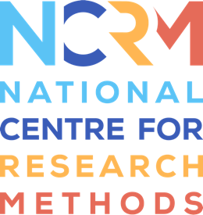
‘I am’ Digital Stories

Key questions to consider for screening and
sharing the ‘I am’ Digital Stories.

Key activity | Key questions | Key considerations for your project related to these questions
Initial ‘screening’ – this is typically a smaller-scale sharing of the Story that is intimate and with the people who know the person well | What does the person (the storyteller) want to happen with their Story at the end of the project?  If they would like a celebratory ‘screening’, who would they like to attend and how would they like to do it (in-person, online)?  If the person is not able to express a view, what are the best interests of that person that need to be considered and who will make the decision?
Wider sharing in public forums – this can be in talks, training, presentations, teaching and on project websites | Do you have a project website through which you will aim to share the research?  What kinds of audience are you seeking to impact through the outputs of your research? Whose views do you want to influence?  Will the Stories only be shown or shared in these contexts, or will the links be available so that people can view the Stories in their own time?
Sharing via a data repository (e.g. UKDS ReShare) – this is a requirement for all UKRI-funded research but may also be worth considering for other research too | When and how have you made this option clear for participants? (see Resource 3 on Ethical Considerations)  Has the version of the Story being deposited fully explored and managed the anonymity and / confidentiality of all the people in the Story?  Have the appropriate permissions been gained from individuals and (where relevant) companies, organisations or settings (e.g., use of school logos, music, copyrighted images) for the public use of the Story?

National Centre for Research Methods (NCRM)
Social Sciences
Murray Building (Bldg 58)
University of Southampton
Southampton SO17 1BJ
United Kingdom
Web www.ncrm.ac.uk
Email info@ncrm.ac.uk
Tel +44 23 8059 4539
Twitter @NCRMUK

