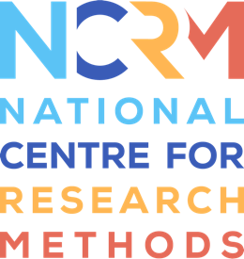
‘I am’ Digital Stories

Mapping template.

What to include, with a few examples |  | Your ideas … | File name & Length once filmed
1. Spaces | Where do you like to be?  Outdoor: your garden, the countryside, by the sea  Inside: relaxing on the sofa in your lounge, in your bedroom, cooking in the kitchen.
‘I’ Statement(s)
2. People and interactions | Who do you like being with?  A friend, family, or a favourite pet … and how you like to spend your time with them.
‘I’ Statement(s)
3. Choices | What do you choose to do … with others or on your own?  Painting, crafts, reading, the crossword, video games cinema, going to the gym, watching TV, reading, arts and crafts, video games.
‘I’ Statement(s)
4. Objects and interests | What are you really interested in and what makes you feel good?  This could be anything: music/film/sport etc., that you do or you’re a fan of, or something you know a lot about, an unusual hobby, or perhaps a long bubble bath or a duvet day!
5. Communication and expression | How do you like to communicate with people?  Do you like to talk or meet online, in the pub, in cafés, when out for a walk? Do you prefer to avoid phone calls and use emails or text messages instead? Do you use other ways to communicate?
6. Support | What do you find challenging or stressful and how do you manage it?  e.g., Going to the dentist, afraid of spiders, flying, crowds, small spaces etc.
‘I’ Statement(s)
7. Skills | What are you good at?  Maybe you are great at Minecraft, Crosswords or Sudoku? Maybe you are a great friend, or good at running, or organising parties?  Sharing an unusual skill would be fun, e.g., being able to complete a Rubik’s cube, tell a joke, doing keepy uppies!
‘I’ Statement(s)

National Centre for Research Methods (NCRM)
Social Sciences
Murray Building (Bldg 58)
University of Southampton
Southampton SO17 1BJ
United Kingdom
Web www.ncrm.ac.uk
Email info@ncrm.ac.uk
Tel +44 23 8059 4539
Twitter @NCRMUK

