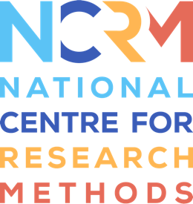
‘I am’ Digital Stories

Creating an 'I am' Digital Story: Describing.
This example is based on work with autistic children in schools, but the text can be adapted as needed for different contexts and groups.

Opposite is an idea you can use to inform your story – it includes the kind of phrases that you could use to develop your own ‘I am... story’.
What sentences could you write in your ‘I am…’ story?
There’s some space for you to write your own sentences.

I am Nathan
I live with my Mum, Dad and brother
I like to cook and then eat the food!
I like being outside
I love swimming and splashing in the water
My favourite place is walking in the woods
I like messy play
I am good at ordering numbers and counting
I use PECS to communicate

You can use this space to write down the phrases about you that you could include:
I AM_______________________________________________________________________________________
___________________________________________________________________________________________

I LIKE______________________________________________________________________________________
___________________________________________________________________________________________

I __________________________________________________________________________________________
___________________________________________________________________________________________

MY________________________________________________________________________________________
___________________________________________________________________________________________

I __________________________________________________________________________________________
___________________________________________________________________________________________
___________________________________________________________________________________________

I __________________________________________________________________________________________
___________________________________________________________________________________________

National Centre for Research Methods (NCRM)
Social Sciences
Murray Building (Bldg 58)
University of Southampton
Southampton SO17 1BJ
United Kingdom
Web www.ncrm.ac.uk
Email info@ncrm.ac.uk
Tel +44 23 8059 4539
Twitter @NCRMUK

