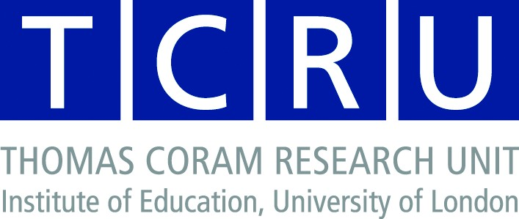
Two day Video methods workshop, 5 and 6 December 2005, Institute of Education University of London
This two day workshop, funded by the Economic and Social Research Council’s National Centre for Research Methods, is part of a programme of workshops and seminars on the theme of qualitative methods in cross national research.
The workshop aims to introduce researchers to two cross-national methods using video. These methods are the Second Order Phenomenological Observation Scheme (Sophos), which uses videos of practice to explore understandings of that practice held by ‘insiders’ such as practitioners, and an action research method using video production and exchange as a research tool with refugee and migrant children. Each day will focus on one of the methods and use a combination of presentations and participatory sessions to explore: the aims and perspectives underpinning each method; the methodological process and issues arising from that including ethics and children’s participation; issues of interpretation and analysis; and some findings and methodological questions emerging from the two projects represented. One question common to both days will be: Does video offer possibilities that are not available using other means, such as talk or writing?
The workshops will be hosted by Claire Cameron and Peter Moss (5 December) and Liesbeth de Block and David Buckingham (6 December) and will include overseas speakers.
PROGRAMME
Monday 5 December: SOPHOS
9.15: Coffee, introductions to the workshop, and to each other. Background to the two methods
10.00 Session 1: led by Helle Krogh Hansen: theory and principles of Sophos.
11.00 Break
11.15 Session 2: led by Claire Cameron: processes for conducting the research, including ethics. Being in an observer group.
12.30 Lunch
13.30 Session 3: led by Jytte Juul Jensen: Cross-national findings from Sohos – what possibilities are offered not available through interviews?
14.45 Break
15.00 Session Four: led by Helle Krogh Hansen and Jytte Juul Jensen: Problematics of interpretation and analysis, focusing on cross-national, cross-discipline dimensions.
16.30 Concluding questions and reflections on the day
17.00 Close
Tuesday 6 December

9.30 Arrival, coffee.

10.00 Session 1: led by Liesbeth de Block, David Buckingham and Peter Howzarth: Introduction to using video production as a method of research with children including discussion of visual ethnography, seeing children as researchers and introduction to CHICAM project

11.15 Break

11.30 Session 2: led by Liesbeth de Block, David Buckingham and Peter Howzarth: Discussion of 3 contrasting productions made by children in CHICAM

12.45 Lunch

13.45 Session 3: Problematics of analysis and interpretation – an example from CHICAM

15.00 Break

15.15 Session 4: Concluding discussion. What overlaps, potential, dilemmas, or ways of taking these methods forward.

16.00 Close

Further details of the use of the method employed in the two projects, both funded by the European Union and coordinated by researchers at the Institute of Education, can be found at http://144.82.31.4/carework/ and http://www.chicam.net/index.html.

