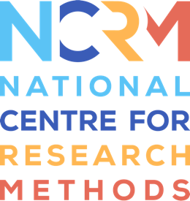

NCRM Pedagogy Network

The aims of the NCRM Pedagogy Network are to:
- develop a coordinated picture of researchers interested in researching and developing research methods teaching and learning in the UK and internationally
- connect those researchers with each other and the National Centre for Research Methods
- support and amplify ‘close-to-practice’ research i.e. small scale local research based on problems in practice, applying critical thinking and use of evidence in developing practice
- build the pedagogic culture in research methods education and training by enhancing awareness of and connections to each other’s work.
Interested members should complete this form and return it to NCRM co-director: Melanie Nind M.A.Nind@soton.ac.uk

NAME:
Are you interested in becoming a member of the NCRM pedagogic network? |  |  | Yes/No
What is your substantive field/discipline?

Do you provide research methods teaching/training yourself? |  |  | Yes/No
If so in what area(s)

What aspects of research methods pedagogy have you been researching/developing?

What work of yours should networks members read?

Are you interested in participating in NCRM ‘Train the trainer’ events to build capacity amongst those providing research methods education and training? |  |  | Yes/No
Are you interested in delivering NCRM ‘Train the trainer’ events/providing learning resources to build capacity amongst those providing research methods education and training? |  |  | Yes/No
Are you willing to be named as a member of the NCRM Pedagogy Network on the NCRM website? |  |  | Yes/No
If yes, what (if any) staff or project webpage and email address would you like to be linked to your name?

