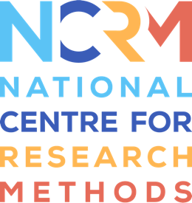

Agenda

SDC-Net: Survey Data Collection Network Meeting

Topic: Future of face-to-face data collection - developing and implementing a revised f2f strategy

Date and Time of Meeting  Tuesday 5th July 2022 @ 13:00 - 15:00 | Venue  Teams

- Welcome and Introduction Gabi Durrant
Note: We are planning to record the event for internal purposes only, such that we do not need to take notes during the meeting. If you have any objections against this, please let us know.

Presentations: (Chair Gabriele Durrant)
Focus today is on strategic and operational challenges for return to face-to-face data collection.
We have about 10-15 mins per presentation.
- Presentation 1: Debrah Harding (Managing Director of the Market Research Society): Back in the field after Covid-19 - What’s changed and how data collection is evolving
- Presentation 2: from a consortium of speakers including Sophie Ainsby (Director of Data Collection, NatCen), Maria Luther (Field Director, Ipsos) and Michelle Lewis (Head of UK Data and Operations, Kantar): Face to Face: returning to a ‘new’ world
- Presentation 3: Alex Lambert (Director of Survey Operations at the ONS): Challenges to Face-to-Face Data Collection
- Presentation 4: Catherine Bromley (Deputy Director of Data Strategy and Infrastructure of ESRC): Panic, Patience, Pragmatism: a research funder’s reflections on the challenges and opportunities facing in-person data collection

- Discussion: Key challenges and priorities in face-to-face data collection (about 30-40 mins) Olga Maslovskaya

- Brief Update from ESRC (max 5 mins) Jo Lake/Catherine Bromley

- Next steps/ future planning (about 15 mins) Gabi Durrant
- Topic of next meeting: The changing role of the interviewer
- Date of next meeting: Sept/October?
- Outputs, guides, online resources from network
- Smaller working groups?
- Any other topics network members would like to discuss? Any feedback?

- AOB Gabi Durrant

