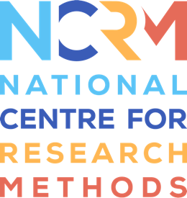

DRAFT Agenda

SDC-Net: Survey Data Collection Network Meeting

Topic: Survey Data Quality – Finding a New Normal?

Date and Time of Meeting  Wednesday 4th May 2022 @ 13:00 - 15:00 | Venue  Teams

- Welcome and Introduction Gabi Durrant
Note: We are planning to record the event for internal purposes only, such that we do not need to take notes during the meeting. If you have any objections against this, please let us know. (Any notes will not be shared outside the core team.)
Chair of discussions: Laura Wilson
- Presentation: Rachel Skentelbery (Deputy Director, ONS) (title tbc)
Ca. 15 mins presentation followed by ca.10-15 mins discussion
- Presentation: Mary Gregory (Deputy Director, Office for Statistics Regulation) (title tbc)
Ca. 15 mins presentation followed by ca. 10-15 mins discussion
- Presentation: Guy Goodwin (CEO, NatCen) (title tbc)
Ca. 15 mins presentation followed by ca. 10-15 mins discussion

- Discussion: Key challenges and research areas in survey data collection (to inform ESRC) Olga Maslovskaya

- Next steps/ future planning Gabi Durrant
Date and topic of next meeting; face-to-face meeting?; smaller working groups; outputs and guides from network.
Topic proposals for the next two meetings are:
1. Future of f2f data collection: Developing and implementing a revised f2f strategy
2. The changing role of the interviewer
Any comments welcome.

- AOB Gabi Durrant

