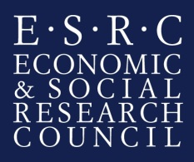
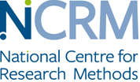

Intention to Submit an Application for National Centre for Research Methods Commissioned Research Projects – phase 2

This form (max 1 A4 side) should be submitted as a .pdf file to the NCRM Research Coordinator, Mrs Penny White, by email to p.c.white@southampton.ac.uk by 16:00 on 16 December 2016.
Principal Investigator’s Name

Date PhD Submitted

Host institution where the grant would be held
Organisation
Division or Department

Primary Topic Area

Provisional Project Title

Summary
Describe the proposed research in simple terms

